**Experiment No. 6**

Aim: To perform remote login using Telnet server.

Requirement: Windows/Linux OS in P.C., CISCO Packet Tracer.

Theory:

Telnet:

Telnet is a network protocol used to virtually access a computer and to provide a two-way, collaborative and text-based communication channel between two machines. It follows a user command Transmission Control Protocol/Internet Protocol (TCP/IP) networking protocol for creating remote sessions. On the web, Hypertext Transfer Protocol (HTTP) and File Transfer Protocol (FTP) simply enable users to request specific files from remote computers, while, through Telnet, users can log on as a regular user with the privileges they are granted to the specific applications and data on that computer.

Telnet Working:

Telnet is a type of client-server protocol that can be used to open a command line on a remote computer, typically a server. Users can utilize this tool to ping a port and find out whether it is open. Telnet works with what is called a virtual terminal connection emulator, or an abstract instance of a connection to a computer, using standard protocols to act like a physical terminal connected to a machine.

Users connect remotely to a machine using Telnet, sometimes referred to as Telnetting into the system. They are prompted to enter their username and password combination to access the remote computer, which enables the running of command lines as if logged in to the computer in person. Despite the physical location of users, their IP address will match the computer logged in to rather than the one physically used to connect.

Telnet using CISCO Packet Tracer:

1) Configuring Switch: 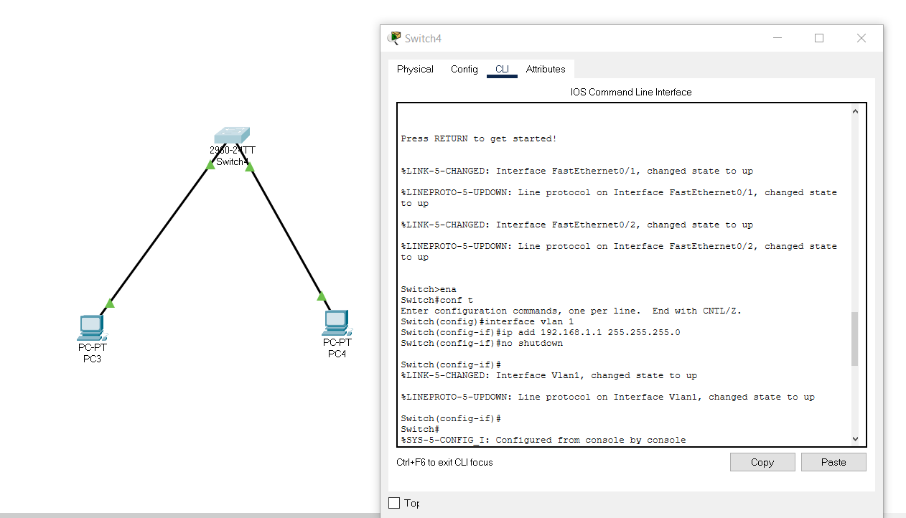

2) Pinging switch from PC3 and PC4:

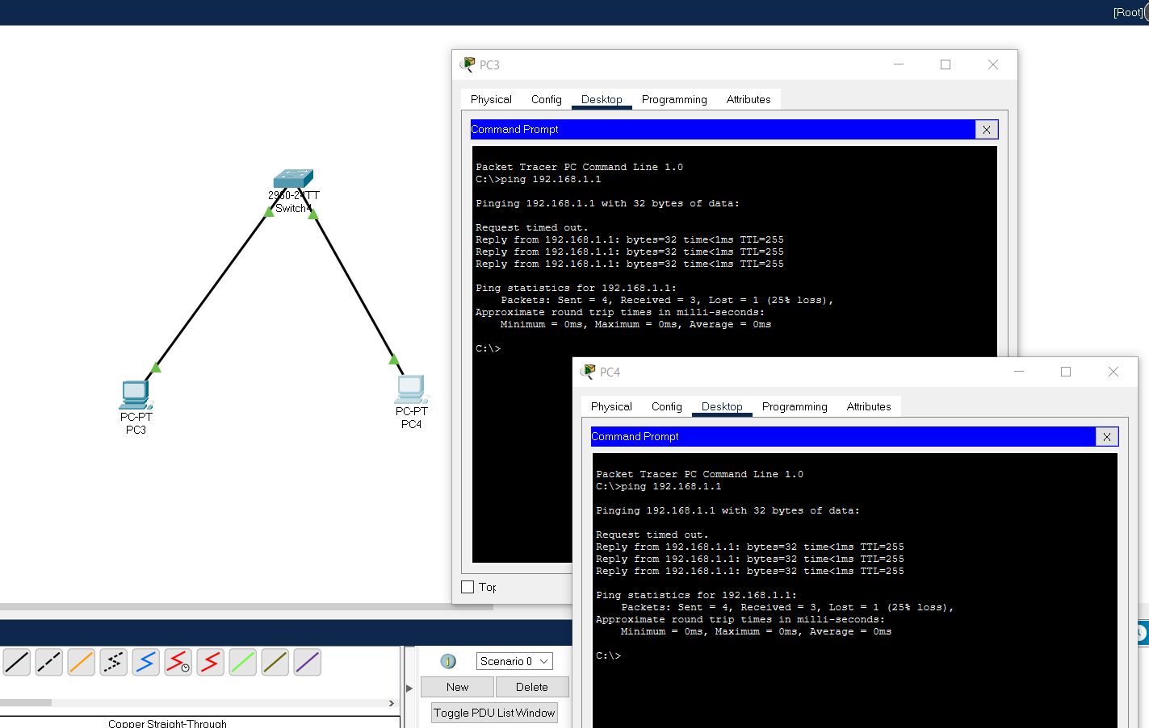

3) Configuring switch(Telnet Server) for remote login using Telnet:

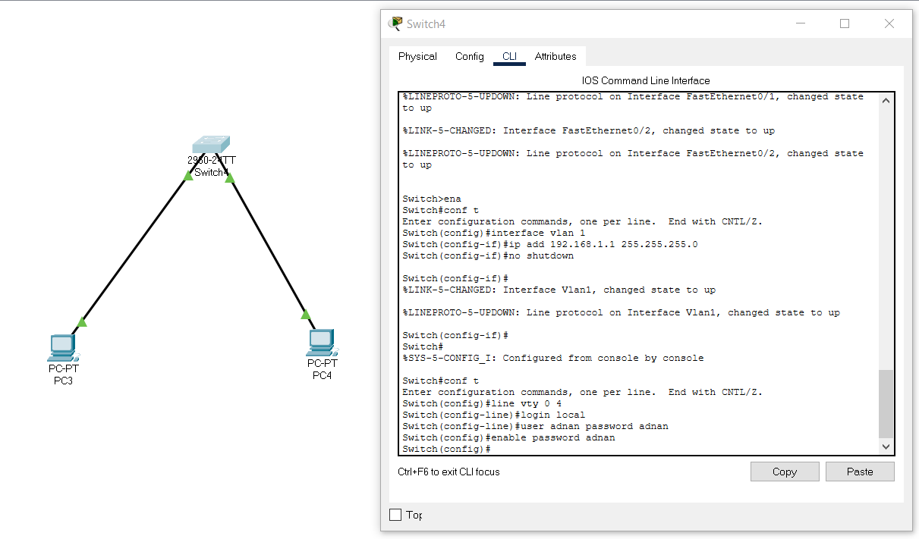

4) Remote login from PC3 to Telnet Server using telnet command:

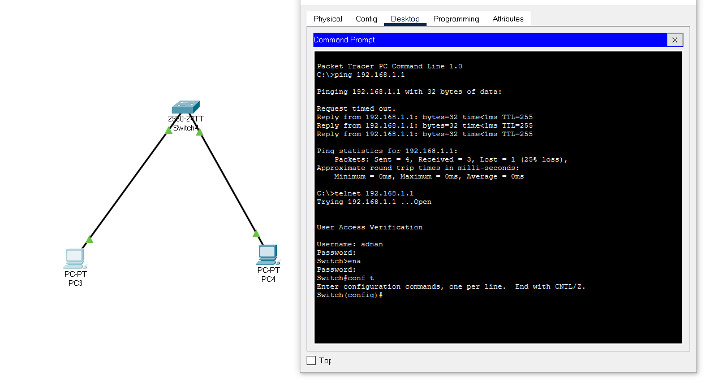

Conclusion: We have successfully remote login from P.C. to Telnet Server by performing proper configuration in CISCO Packet Tracer.